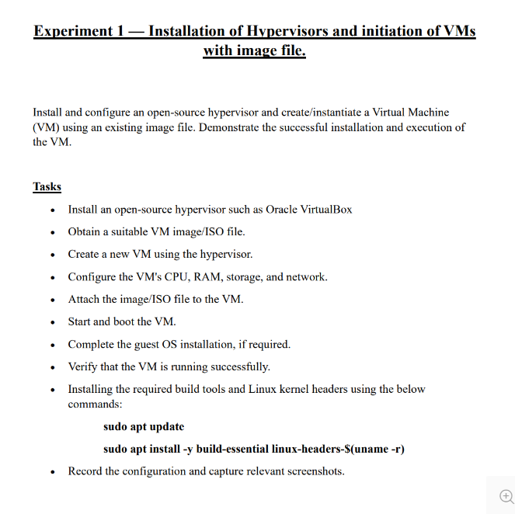

- Installing and opening Oracle Virtual Machine

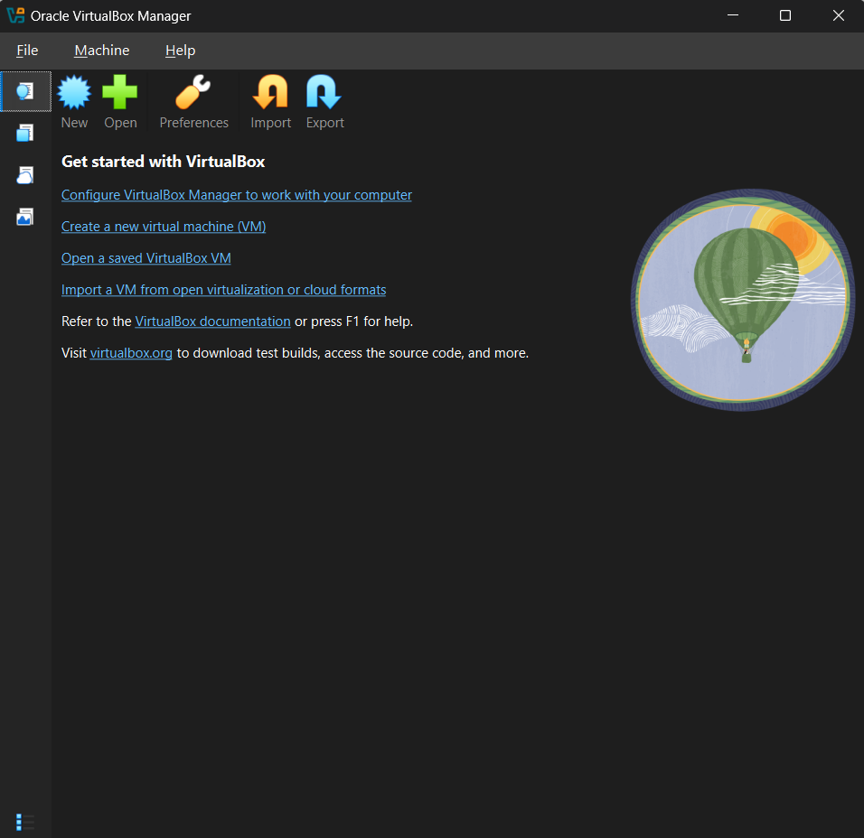

- Uploading ISO file for OS installation in VM
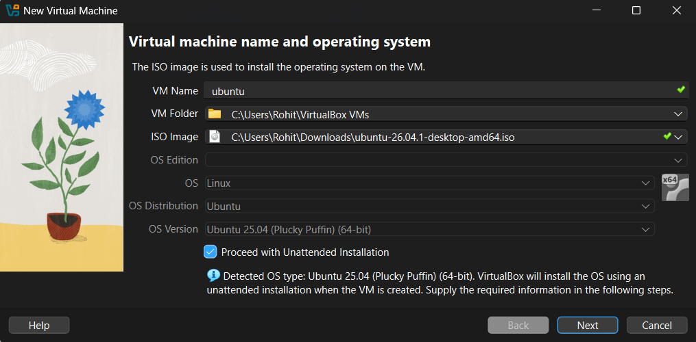

- Virtual Machine Configuration
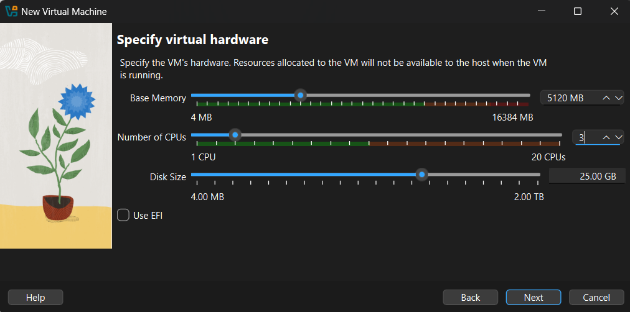

- Virtual Machine Configuration
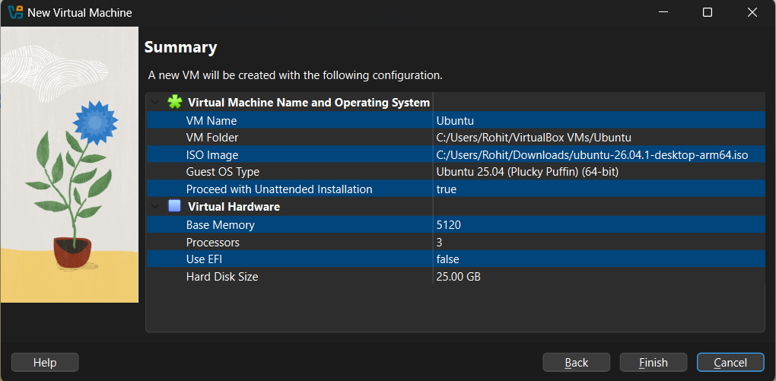

- Ubuntu installation in VM
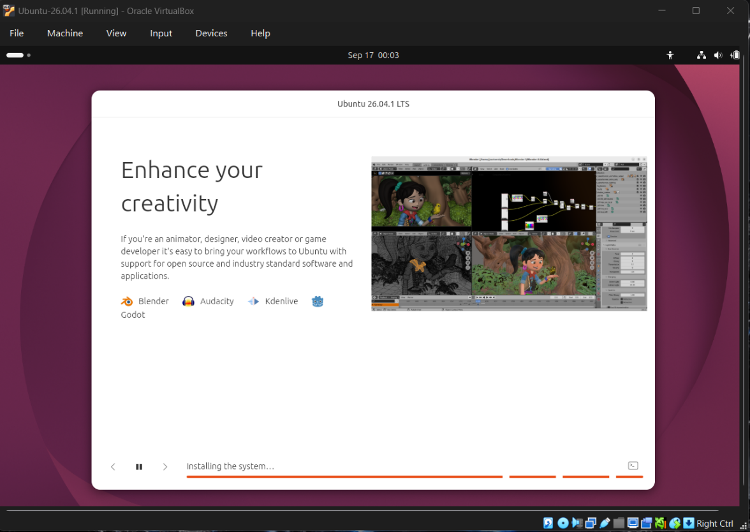

- Ubuntu Home Screen
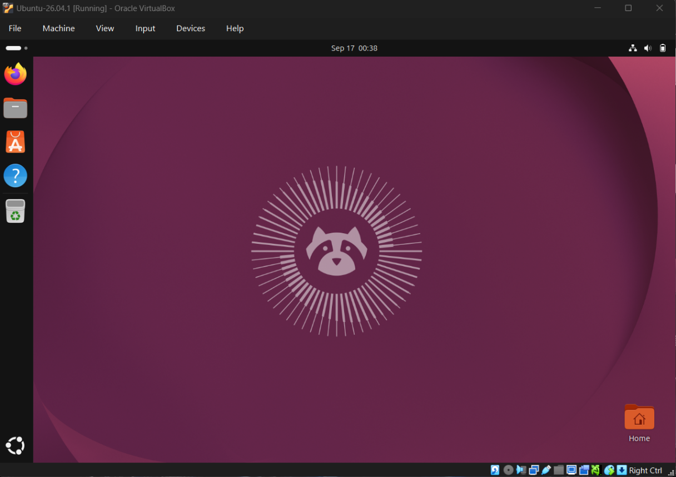

- Install build tools & kernel headers using following command
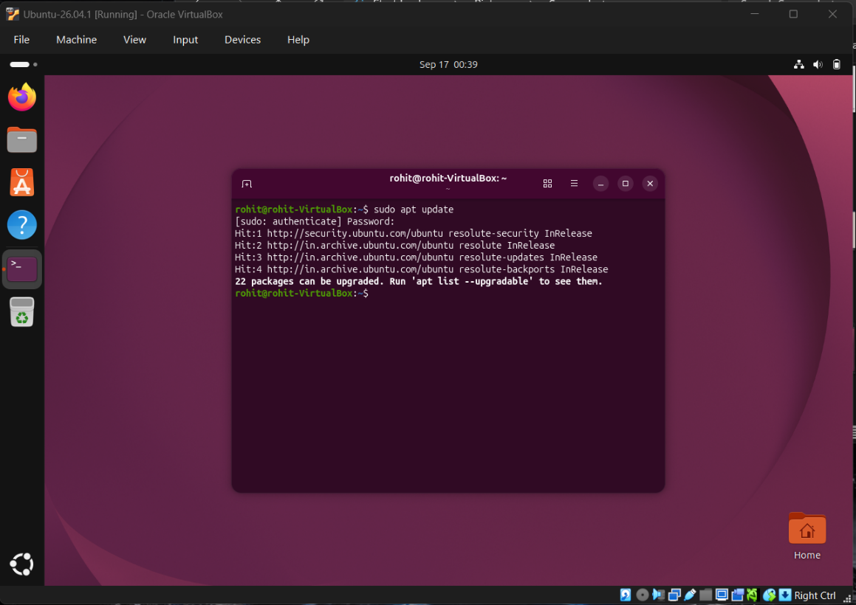
- sudo apt update

- sudo apt install -y build-essential linux-headers-$(uname -r)
